**Step 1**:Install Subversion-SVN Team Provider

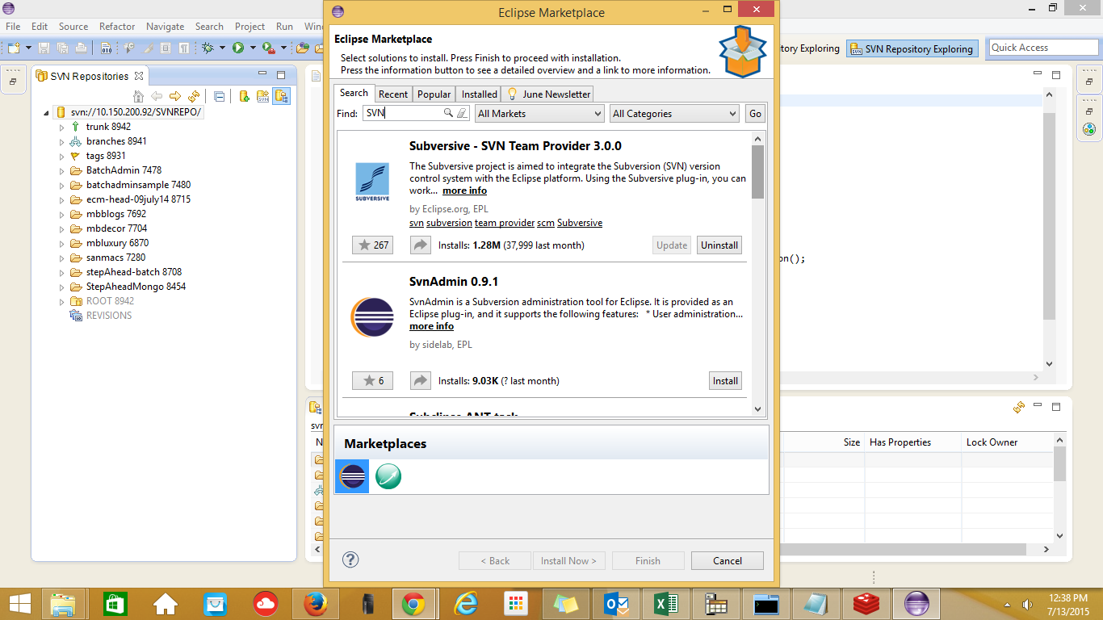

**Step 2**:Install Connector

**Follow this path:**

Window->Preferences->Team->SVN->SVN Connector.

**Make sure you have install 64 BIT connector**

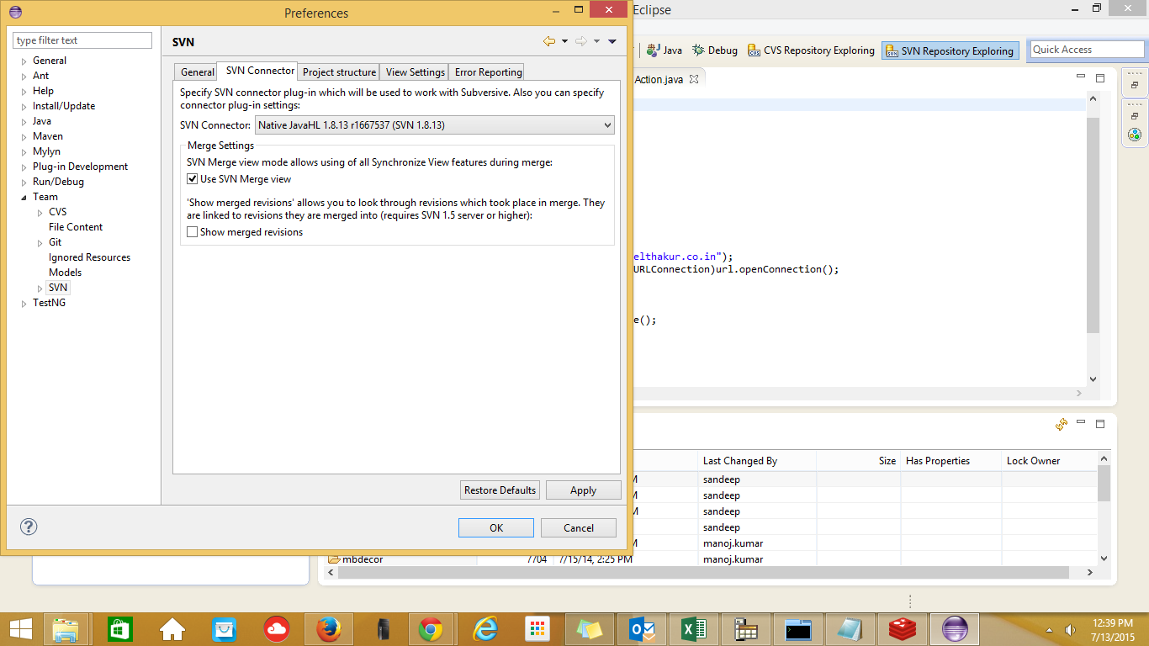

**Step 3**: Configuration of SVN

**username**:ranjan

**password**:ran@jan456

